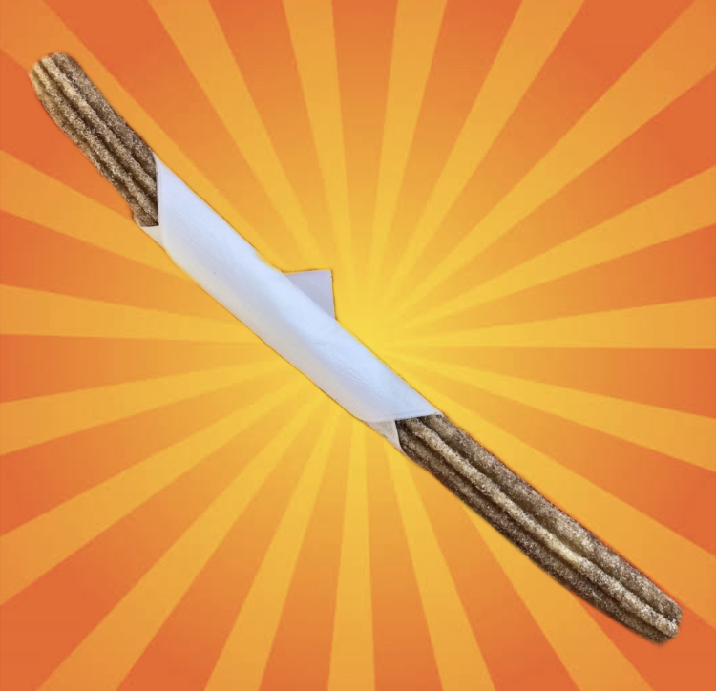

**16 inch Churro with Cinnamon Sugar**

**$5**